**Practical 1:**

|  |
| --- |
| A) Introduction to Python Programming. Installation & Configuration of Python. Along with its all-major editors, IDLE, Pycharm, Anaconda, Jupyter, Interpreter etc. |

B) Write a python program to calculate simple intrest.

**Solution:**

Python is a popular programming language. It was created by Guido van Rossum, and released in 1991.

It is used for:

web development (server-side),

software development,

mathematics,

system scripting.

Step 1: Select Version to Install Python

Visit the official page for Python <https://www.python.org/downloads/> on the Windows operating system. Locate a reliable version of Python 3, preferably version 3.10.11, which was used in testing this tutorial. Choose the correct link for your device from the options provided: either Windows installer (64-bit) or Windows installer (32-bit) and proceed to download the executable file.

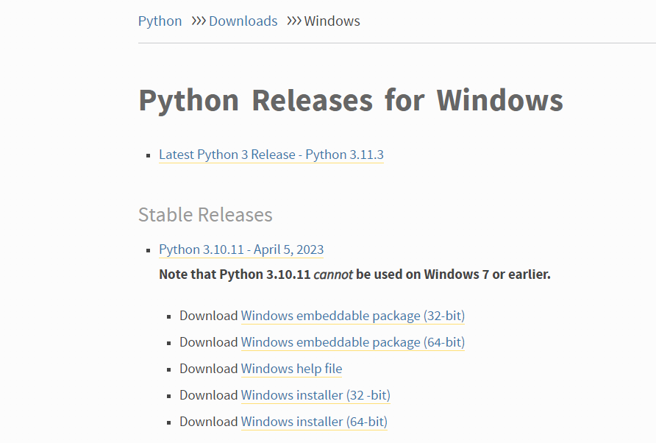

Python Homepage

Step 2: Downloading the Python Installer

Once you have downloaded the installer, open the .exe file, such as python-3.10.11-amd64.exe, by double-clicking it to launch the Python installer. Choose the option to Install the launcher for all users by checking the corresponding checkbox, so that all users of the computer can access the Python launcher application.Enable users to run Python from the command line by checking the Add python.exe to PATH checkbox.

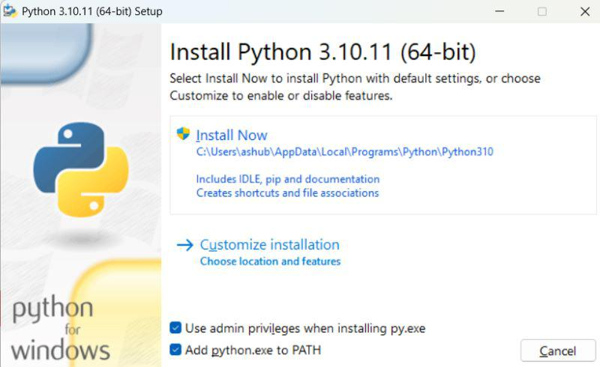

Python Installer

After Clicking the Install Now Button the setup will start installing Python on your Windows system. You will see a window like this.

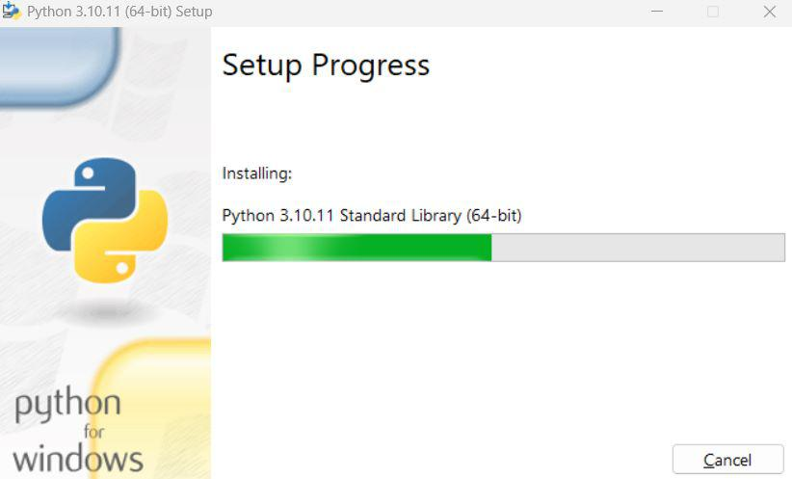

Python Setup

Step 3: Running the Executable Installer

After completing the setup. Python will be installed on your Windows system. You will see a successful message.

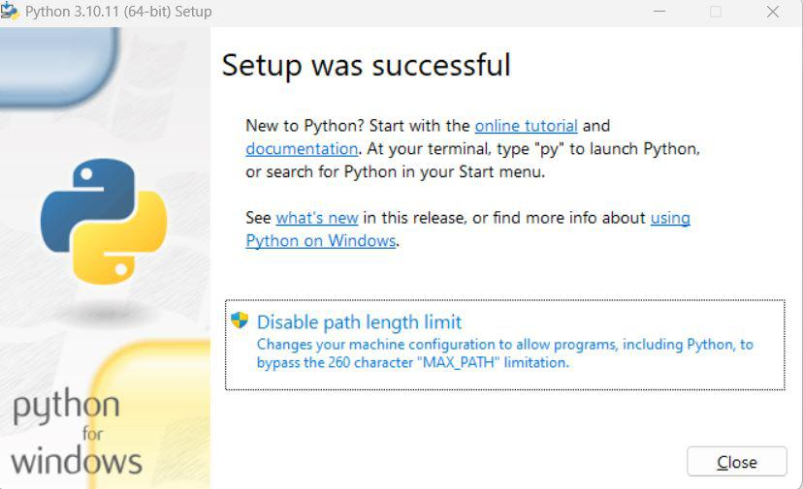

Python Successfully installed

Step 4:  Verify the Python Installation in Windows

Close the window after successful installation of Python. You can check if the installation of Python was successful by using either the command line or the Integrated Development Environment (IDLE), which you may have installed. To access the command line, click on the Start menu and type “cmd” in the search bar. Then click on Command Prompt.

python --version



Download and install Anaconda:

Head over to anaconda.com and install the latest version of Anaconda. Make sure to download the “Python 3.7 Version” for the appropriate architecture.

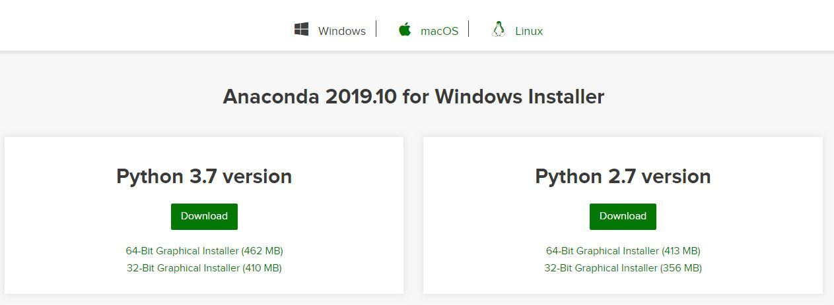

Begin with the installation process:

Getting Started:

Getting through the License Agreement:

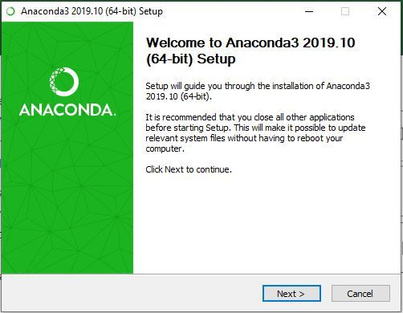

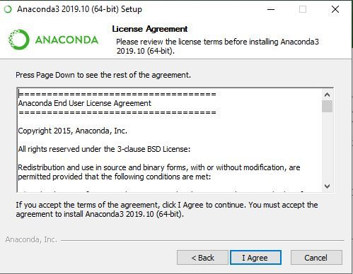

Select Installation Type: Select Just Me if you want the software to be used by a single User

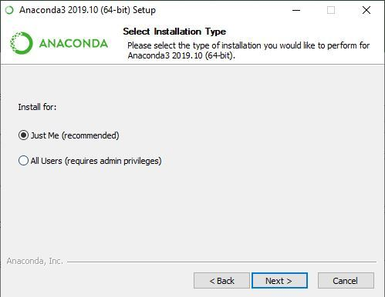

Choose Installation Location:

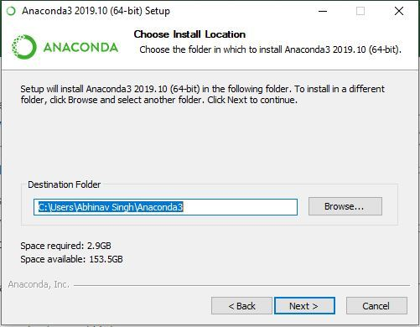

Advanced Installation Option:

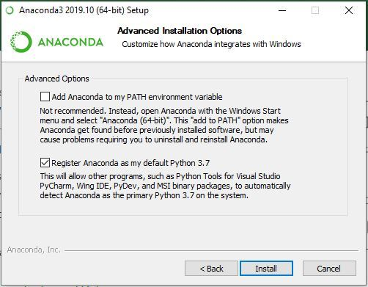

Getting through the Installation Process:

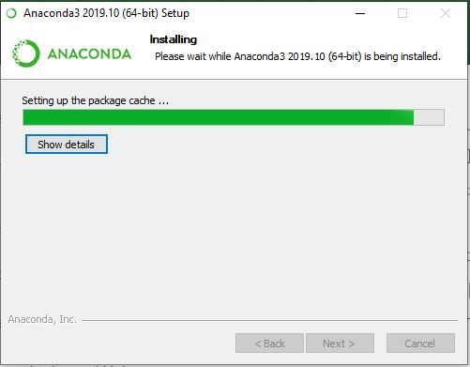

Recommendation to Install Pycharm

:  
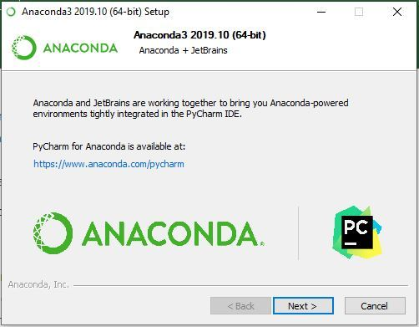

Finishing up the Installation:

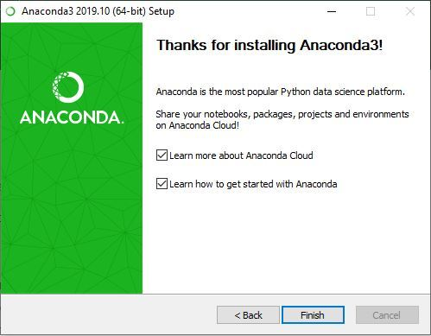

Working with Anaconda:

Once the installation process is done, Anaconda can be used to perform multiple operations. To begin using Anaconda, search for Anaconda Navigator from the Start Menu in Windows

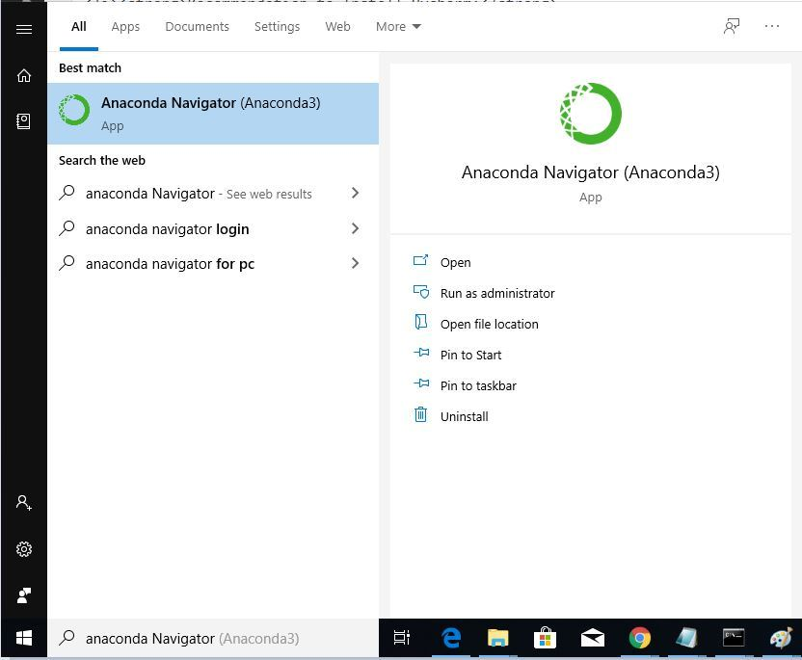

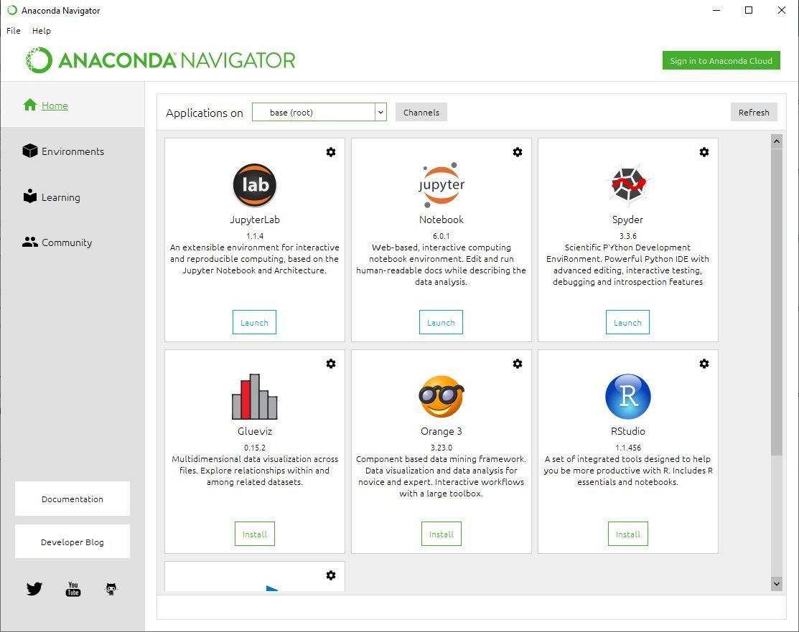

IDLE:

An IDE (Integrated Development Environment) is software that combines commonly used developer tools into a compact GUI (graphical user interface) application. It is a combination of tools like a code editor, code compiler, and code debugger with an integrated terminal.

Common Features of an IDE

IDEs provide a broad variety of features which typically consist of:

1. Editor: Typically a text editor can help you write software code by highlighting syntax with visual cues, providing language-specific auto-completion, and checking for bugs as you type.

2. Compiler: A compiler interprets human-readable code into machine-specific code that can be executed on different operating systems like Linux, Windows, or Mac OS. Most IDEs usually come with built-in compilers for the language it supports.

3. Debugger: A tool that can assist developers to test and debug their applications and graphically point out the locations of bugs or errors if any.

4. Build-in Terminal: Terminal is a text-based interface that can be used for interacting with the machine’s operating system. Developers can directly run the scripts or commands within an IDE with a built-in terminal/console.

5. Version Control: Version control helps bring clarity to the development of the software. Some IDEs also support version control tools like Git through which a user can track and manage the changes to the software code.

6. Code snippets: IDEs support code snippets that are usually used to accomplish a single task and can also reduce redundant work to some great extent.

7. Extensions and Plugins: Extensions and Plugins are used to extend the functionality of the IDEs with respect to specific programming languages.

8. Code navigation: IDEs come with tools like code folding, class and method navigation, and refactoring tools that make it simple to go through and analyze code.

Jupyter NoteBook:

The Jupyter NoteBook is an open-source web application that allows you to create and share documents that contain live code, equations, visualizations and narrative text.

It is a popular tool among data scientists, researchers, and educators for interactive computing and data analysis.

The name “Jupyter” is derived from the three core programming languages it originally supported: Julia, Python and R

1. Key features of Jupyter Notebook

* Several programming languages are supported.
* Integration of Markdown-formatted text.
* Rich outputs, such as tables and charts, are displayed.
* flexibility in terms of language switching (kernels).
* Opportunities for sharing and teamwork during export.
* Adaptability and extensibility via add-ons.
* Integration of interactive widgets with data science libraries.
* Quick feedback and live code execution.
* Widely employed in scientific research and education.

(B) Write a python program to calculate simple intrest.

Input:

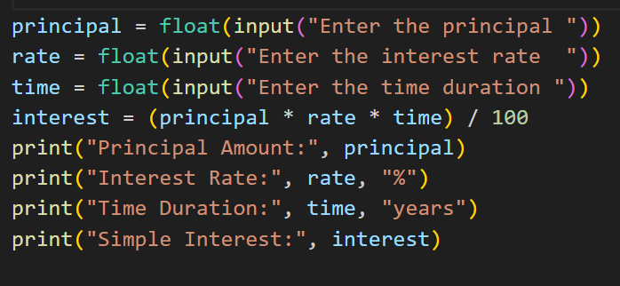

Output:

